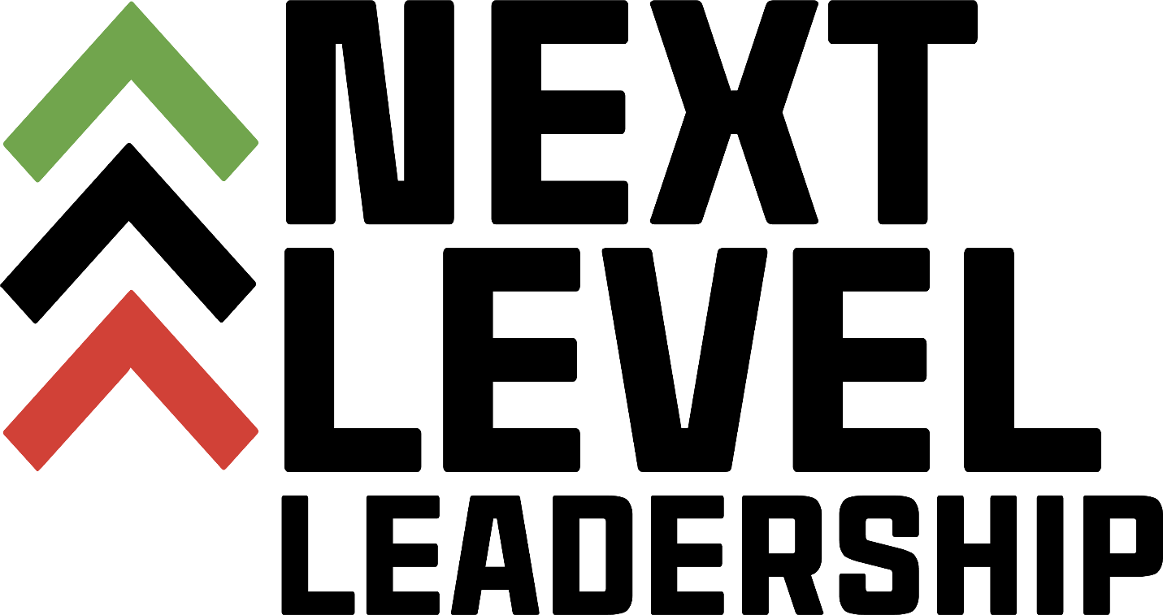

**Information and Application Packet**



Dear Applicant:

Thank you for your interest in Next Level Leadership, Inc. We are a leadership development organization whose mission is to intentionally develop well informed, knowledgeable African American leaders for the purpose of leading our communities, cities and state into the future. Our vision is to create a pipeline primarily of African Americans to prepare for leadership positions within our society to ensure civil liberties, equity, and equality on every level.

This class is a unique mixture of leadership curriculum, government, community service and activities planning.

If this sounds like, a program for you, please complete the attached application. Please pay special attention to due dates and signatures necessary. Since we receive so many applications and can only accept a limited number of applicants each year, any applications that are late or incomplete will not be accepted.

Thank you for your interest.

Sincerely,

Arlena

Arlena Hawthorne

President

**Application four step process:**

**Step 1** – Application

**Step 2** - Essay

**Step 3** – Recommendation Letter from a non-family member who has known you for at least three years.

**Step 4** - Selected participants will be invited to interview. The interview will be conducted by the Board of Directors.

***Please see website for application deadline**.** Late applications will not be accepted.

**Acceptance:**

Once you have submitted a complete application, recommendation letter and have participated in the interview process by the Board of Directors, you will then be considered to become a participant in the class.

Applicants will receive an email confirmation as to whether or not they have been selected for the class.

Once our final Leadership Class has been determined, applicants will receive additional class information.

 **Application**

*Please note this is the print and mail option.*

*An on-line option at nxtlevelleadership.org*

**Section A:**

First Name________________________________________________

Last Name ________________________________________________

Middle Name ______________________________________________

Mailing Address ____________________________________________

City ___________________ State ________ Zip Code _____________

Phone number _______________ Email ________________________

Occupation________________________________________________

Place of Employment________________________________________

Emergency Contact Name ___________________________________

Emergency Contact Phone ___________________________________

**Section B:**

List Professional Affiliations:

List Community Service Activities and Time Served

**Section C:**

**Short Answer Questions**

Directions: Answer each of the following questions in 250 words or less. Give specific, detailed and personal examples.

What are two examples from your life where you demonstrated leadership?

What do you value and how does that shape your character?

**Section D:**

Essay Question

Directions: Answer the following question in an essay of a minimum of 250 and not more than 500 words. Give specific, detailed and personal examples.

**Describe a time when you have compromised your values. What were the consequences of that, and how did you grow from that experience?**

**Section E:**

**Personal Statement**

In 50 words or less, explain why you would like to attend this leadership class and what benefit do you expect to gain after the program.

**Section F:**

Send completed application and $25.00 non-refundable application fee money order to:



**Next Level Leadership, Inc.**

**P.O. Box 32246**

**Charlotte, North Carolina 28232**

***DO NOT attach or enclose any documents other than the***

***requested information.***

**Questions:**

Please feel free to contact the Program Directors:

* Arlena Hawthorne (704) 607-7990 Email:Arlena_h@hotmail.com
* Nicholas Glass (704-497-3227) Email – nglass529@gmail.com