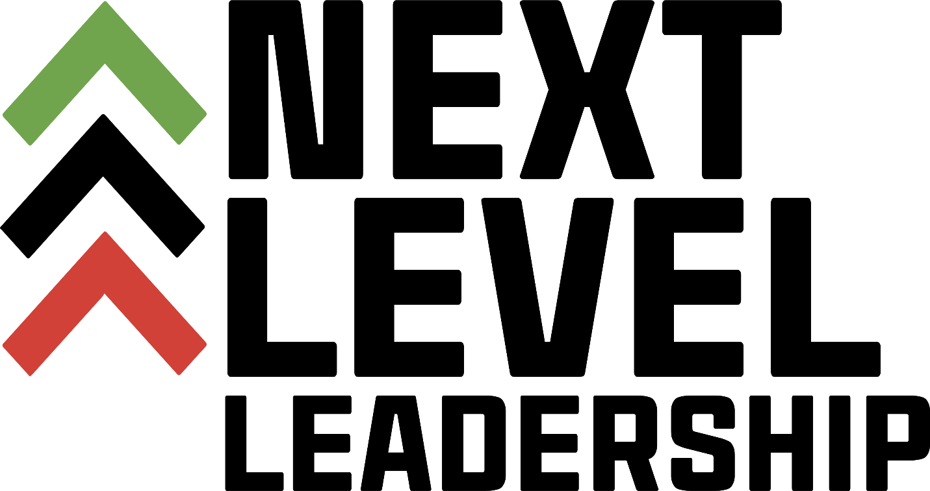

Information and Application Packet

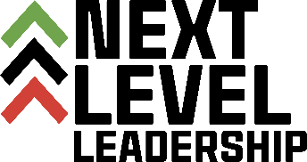

Dear Applicant:

Thank you for your interest in Next Level Leadership, Inc. We are a leadership development organization whose mission is to intentionally develop well informed, knowledgeable African American leaders for the purpose of leading our communities, cities and state into the future. Our vision is to create a pipeline primarily of African Americans to prepare for leadership positions within our society to ensure civil liberties, equity, and equality on every level.

This class is a unique mixture of leadership curriculum, government, community service and activities planning.

If this sounds like, a program for you, please complete the attached application. Please pay special attention to due dates and signatures necessary. Since we receive so many applications and can only accept a limited number of applicants each year, any applications that are late or incomplete will not be accepted.

Thank you for your interest.

Sincerely,

Arlena

Arlena Hawthorne
President

Program Overview:

Next Level Leadership, Inc. is a 13-week intense leadership and professional development program. It is designed to challenge you and grow your leadership skills for the world of today and tomorrow. Subject matter experts and industry/community leaders facilitate training that will take your competencies to the next level of leadership.

This year, we have implemented Covid protocols to protect the health and safety of program participants and facilitators. All sessions will be delivered virtually until we are confident that bringing the cohort together in person will not pose a health risk.

The classes are staggered to accommodate working professionals and families. Classes are held on Tuesdays from 6:00pm - 8:30pm and Saturdays from 9:00am - 3:00pm.

Classes will begin on April 5th. Programming includes but not limited to; Orientation, Leadership in the African American Community, Organizational Development, Health & Wellness, Communication Skills, Grant Writing, and topics focused on increasing your leadership competencies. You will also have the opportunity to work together on a class project to benefit the African American community.

Fees:

The cost of your Next Level Leadership training begins with a non-refundable application fee of $25.00. This may be paid online with your completed application. Personal checks are not accepted.

Additionally, there is a Program Fee of $250 to be paid by March 31st.

Mail to: Next Level Leadership, Inc., P.O. Box 32246, Charlotte, NC 28232.The application deadline is February 28, 2022.

Guidelines:

This is a six-month commitment. It is expected that accepted participants attend the class for the entire duration.

It is extremely important that participants who are selected remember that they are to serve as positive role models and examples while in class as well as in our community.

Participants admitted to the Next Level Leadership Program:
  - Only in the case of an emergency, can the applicant miss (2) classes
  - Three (3) tardies equal an absence (This means arriving 15 minutes late or leaving before the class ends)
  - Must participate in classroom discussions
  - Must participate in a class project that will be evaluated by the Board of Directors
  - Be accountable for following through with an individual and/or committee commitments and/or responsibilities

Acceptance Process:

This class is a unique mixture of leadership curriculum government, community service and activities planning. If this sounds like the class for you, please complete the application below.

Please pay special attention to due dates and signatures necessary. Since we receive so many applications and can only accept a limited number of applicants each year, any applications that are late or incomplete will not be accepted.

Application four step process:

Step 1 – Application

Step 2 - Essay

Step 3 – Recommendation Letter from a non-family member who has known you for at least three years.

Step 4 – Interviews will be conducted on. March 7 – 12, 2022 Students will be invited by email to sign up for an interview. The interview will be conducted by the Board of Directors.

The application deadline is February 28, 2022. Late applications will not be accepted.

Acceptance:

Once you have submitted a complete application, recommendation letter and have participated in the interview process by the Board of Directors, you will then be considered to become a participant in the class.

Applicants will receive an email confirmation as to whether or not they have been selected for the class the week of March 20th, 2022.

Once our final Leadership Class has been determined, applicants will receive additional class information.

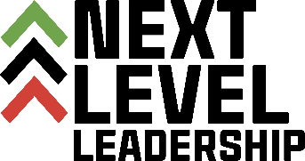
Application
Please note this is the print and mail option.
An on-line option atnxtlevelleadership.org

Section A:

First Name________________________________________________

Last Name ________________________________________________

Middle Name ______________________________________________

Mailing Address ____________________________________________

City ___________________ State ________ Zip Code _____________

Phone number _______________ Email ________________________

Occupation________________________________________________

Place of Employment________________________________________

Emergency Contact Name ___________________________________

Emergency Contact Phone ___________________________________

Section B:

List Professional Affiliations:

List Community Service Activities and Time Served

Section C:

Short Answer Questions
Directions: Answer each of the following questions in 250 words or less. Give specific, detailed and personal examples.

What are two examples from your life where you demonstrated leadership?

What do you value and how does that shape your character?

Section D:
Essay Question
Directions: Answer the following question in an essay of a minimum of 250 and not more than 500 words. Give specific, detailed and personal examples.

Describe a time when you have compromised your values. What were the consequences of that, and how did you grow from that experience?

Section E:

Personal Statement
In 50 words or less, explain why you would like to attend this leadership class and what benefit do you expect to gain after the program.

Section F:
A $25.00 non-refundable application fee is required with the application

Next Level Leadership, Inc.
P.O. Box 32246
Charlotte, North Carolina 28232

DO NOT attach or enclose any documents other than the
requested information.

Questions:
Please free to contact the Program Directors:
- Arlena Hawthorne (704) 607-7990 Email: Arlena_h@hotmail.com or
- Jaslyn Roberts (980) 277-1394 Email: jivroberts@gmail.com

